11 Out of Boundary Paths
Aim
To find the number of ways a ball can move out of a grid boundary in exactly N steps.
Pseudocode
1. Start
2. Read m, n, N, i, j.
3. If the ball moves outside the grid, return 1.
4. If N = 0, return 0.
5. Move the ball in four directions.
6. Add the results of all directions.
7. Return the total number of ways.
8. Stop
Python code
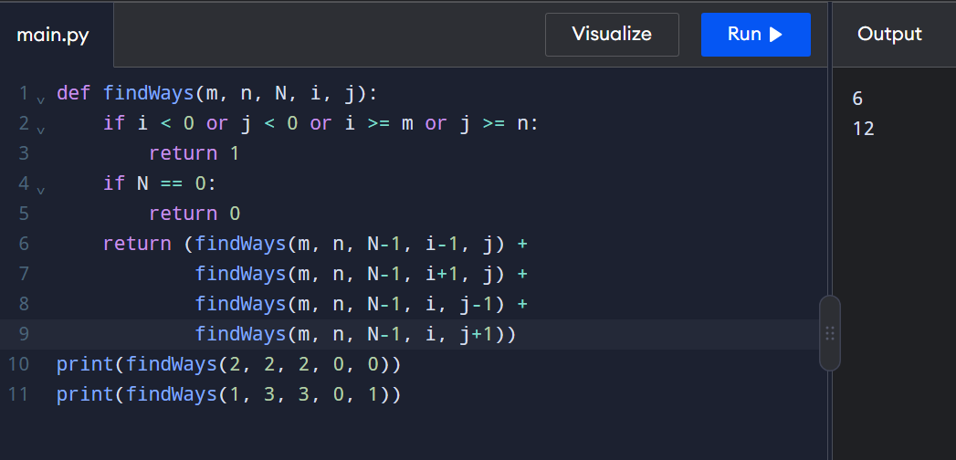
Input
2 2 2 0 0
Output
6
Time Complexity: O(4N)O(4^N)O(4N),
Space Complexity: O(N)O(N)O(N).
Result: Thus, the Python program to find the number of ways a ball can move out of the grid boundary in exactly N steps was executed successfully.

12 House Robber II (Circular Street)
1. Aim
To find the maximum amount of money that can be robbed from houses arranged in a circle without robbing two adjacent houses.
2. Pseudocode
START
1. Read the array nums.
2. If only one house exists, return its money.
3. Calculate maximum money by excluding the last house.
4. Calculate maximum money by excluding the first house.
5. Return the larger value.
6. STOP
Python code
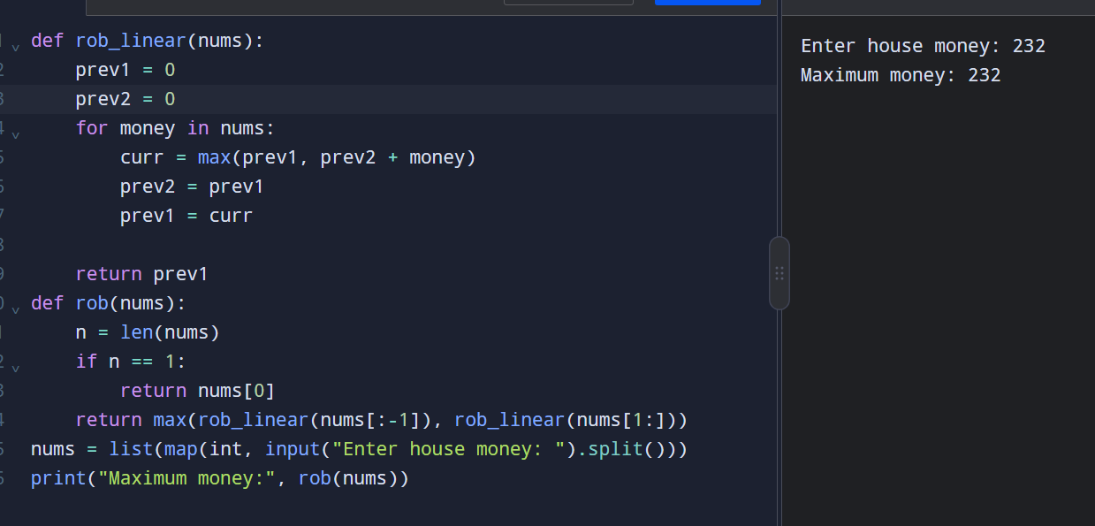
Time Complexity: $O\left(n\right)$
Space Complexity: $O\left(n\right)$due to creating sliced arrays.
Result
Thus, the program successfully finds the maximum amount of money that can be robbed from circularly arranged houses without triggering the security system.

13 Climbing Stairs
Aim
To find the number of distinct ways to climb a staircase by taking either 1 or 2 steps at a time.
Pseudocode
START
1. Read n.
2. If n <= 2, return n.
3. Set a = 1, b = 2.
4. Repeat from 3 to n:
c = a + b
a = b
b = c
5. Print b.
STOP
Python code
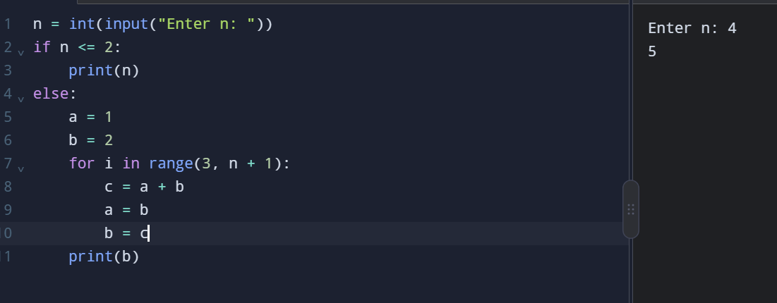
Input:4
Output:5
Time Complexity: $O\left(n\right)$
Space Complexity: $O\left(1\right)$
Result
Thus, the program successfully calculates the number of distinct ways to climb the staircase by taking either 1 or 2 steps at a time.

14 Unique Paths in a Grid
1. Aim
To find the number of unique paths for a robot to reach the bottom-right corner of an $m×n$grid by moving only right or down.
2. Pseudocode
START
1. Read m and n.
2. Create a grid dp[m][n].
3. Set the first row and first column to 1.
4. For each remaining cell:
dp[i][j] = dp[i-1][j] + dp[i][j-1]
5. Print dp[m-1][n-1].
STOP
Python Code
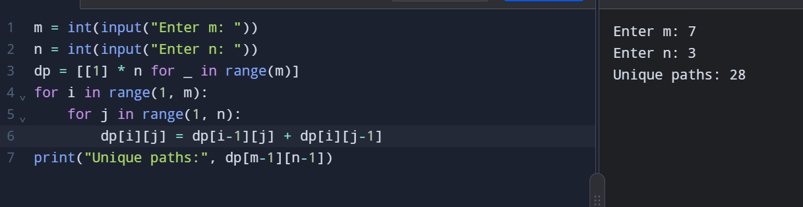
Input:
3
2
Output:
Unique paths: 3
Time Complexity: $O\left(m×n\right)$
Space Complexity: $O\left(m×n\right)$
Result
Thus, the Python program successfully calculates the number of unique paths for the robot to reach the bottom-right corner of the grid by moving only right or down.

15 Large Groups in a String
Aim: To find and return the start and end indices of all groups containing three or more consecutive same characters.
Pseudocode:
START
1. Read string s.
2. Set i = 0 and create an empty list.
3. Check consecutive characters that are the same.
4. If a group has 3 or more characters, store its start and end indices.
5. Repeat until the string ends.
6. Print the list of intervals.
STOP
Python code
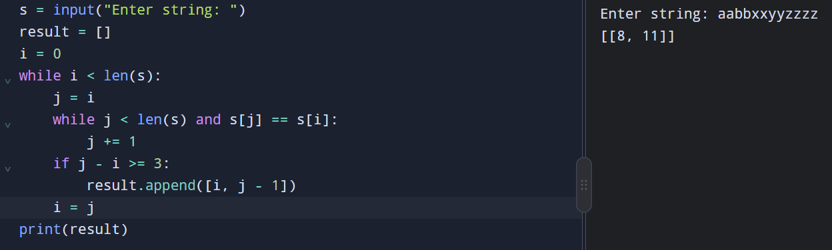
Input 2:
abc
Output 2:
[]
Time Complexity: $O\left(n\right)$
Space Complexity: $O\left(n\right)$
Result: The Python program successfully identifies all large groups and returns their start and end indices.

16 Game of Life
Aim: To find the next state of a grid by applying the Game of Life rules to each cell.
Pseudocode:
START
1. Read the board.
2. Create a copy of the board.
3. For each cell, count its eight live neighbors.
4. Apply the rules:
- Live cell with fewer than 2 neighbors becomes dead.
- Live cell with 2 or 3 neighbors stays alive.
- Live cell with more than 3 neighbors becomes dead.
- Dead cell with exactly 3 neighbors becomes alive.
5. Print the updated board.
STOP
Python code
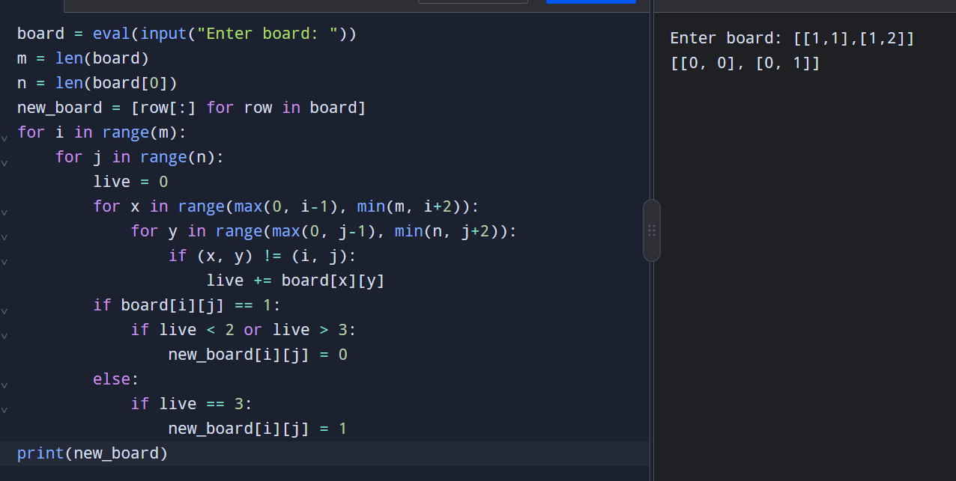
Input 2:
[[1,1],[1,0]]
Output 2:
[[1,1],[1,1]]
Time Complexity: $O\left(m×n\right)$
Space Complexity: $O\left(m×n\right)$
Result: The Python program successfully calculates the next state of the Game of Life board.

17 Champagne Tower
Aim: To calculate how full a particular glass is after pouring champagne into the top glass.
Pseudocode:
START
1. Read poured, query_row, query_glass.
2. Create a tower with 100 rows.
3. Pour champagne into the top glass.
4. If a glass contains more than 1 cup, distribute the excess equally to the two glasses below.
5. Repeat for each row.
6. Print the amount in the required glass, up to 1 cup.
STOP
C code
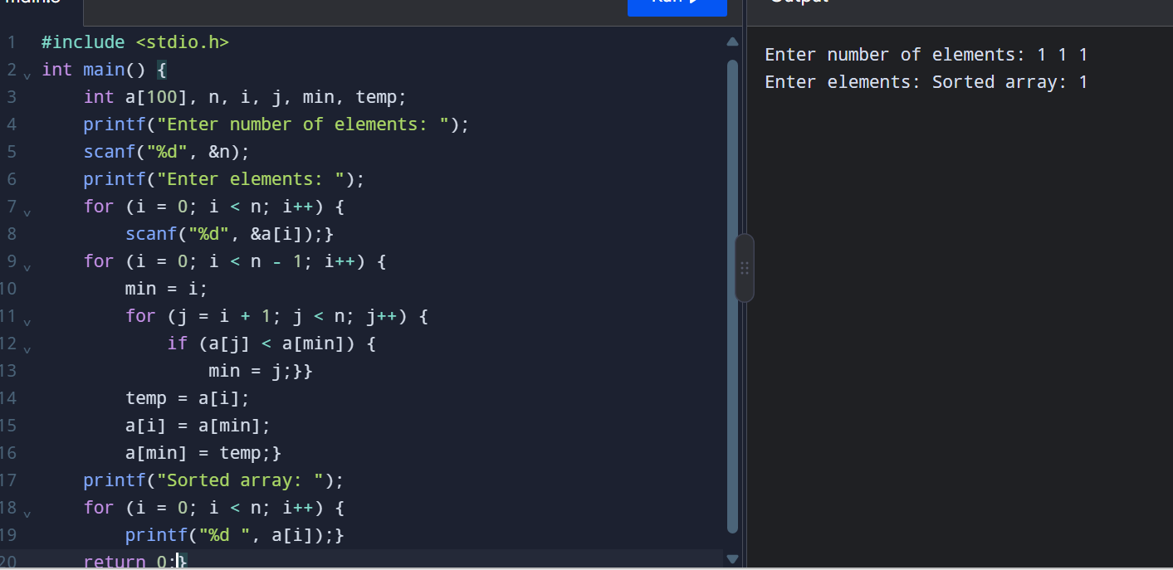
Input 2:
2
1
1
Output 2:
0.50000
Time Complexity: $O\left({100}^{2}\right)$
Space Complexity: $O\left({100}^{2}\right)$
Result: The Python program successfully calculates the fullness of the specified glass.

18 Brute Force — Selection Sort
Aim: To sort a list in ascending order using the Selection Sort algorithm and test empty lists, single elements, identical elements, and negative numbers.
Pseudocode:
START
1. Read the list.
2. For each position, find the smallest element in the remaining list.
3. Swap it with the element at the current position.
4. Repeat until the list is sorted.
5. Print the sorted list.
STOP
Python code
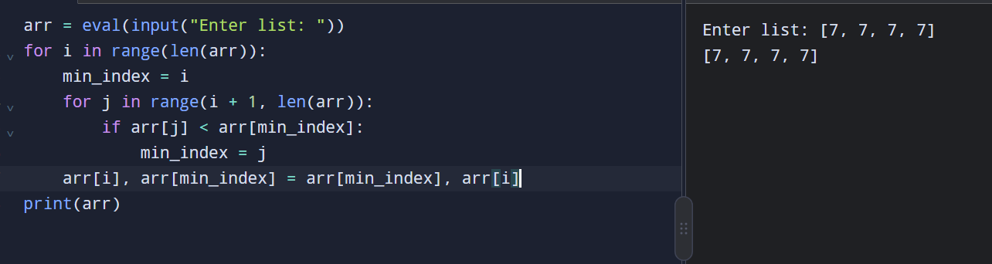

Input | Output
[] | []
[1] | [1]
[7, 7, 7, 7] | [7, 7, 7, 7]
[-5, -1, -3, -2, -4] | [-5, -4, -3, -2, -1]
Time Complexity: $O\left(n^{2}\right)$
Space Complexity: $O\left(1\right)$auxiliary space.
Result: The Python program successfully sorts the list in ascending order using Selection Sort.

19 Selection Sort
Aim: To sort an array in ascending order using the Selection Sort algorithm.
Pseudocode:
START
1. Read n and array elements.
2. Repeat for i = 0 to n-2:
a. Set min = i.
b. Find the smallest element from i+1 to n-1.
c. Swap the smallest element with a[i].
3. Print the sorted array.
STOP
C code
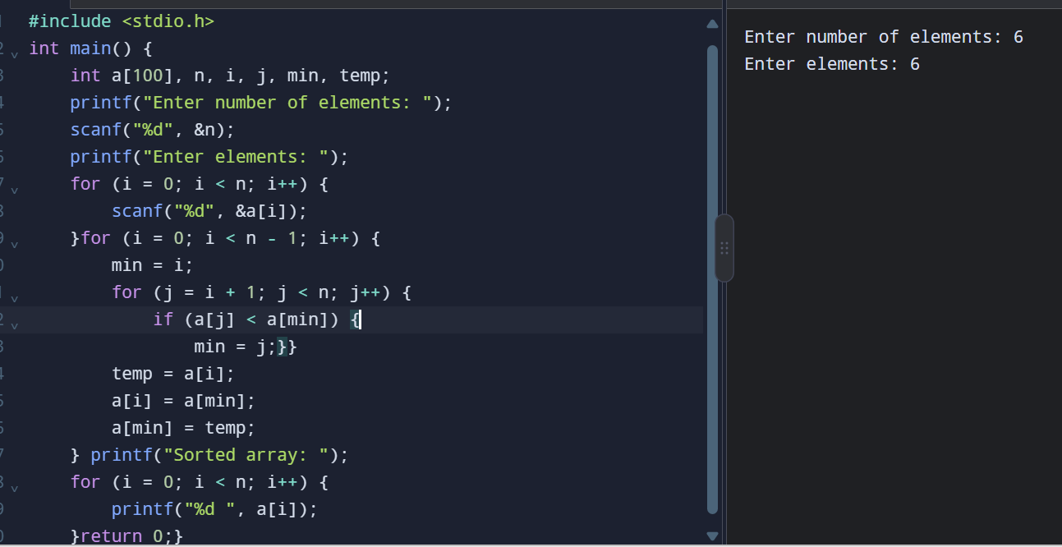
Input:
Enter number of elements: 6
Enter elements: 5 2 9 1 5 6
Output:
Sorted array: 1 2 5 5 6 9
Time Complexity: $O\left(n^{2}\right)$in the best, average, and worst cases.
Space Complexity: $O\left(1\right)$auxiliary space.
Result: The C program successfully sorts the array in ascending order using Selection Sort.

20 Optimized Bubble Sort
Aim: To modify Bubble Sort to stop early when the list is already sorted.
Pseudocode:
START
1. Read array elements.
2. Repeat passes through the array.
3. Set swapped = 0 at the start of each pass.
4. Compare adjacent elements and swap if needed.
5. If a swap occurs, set swapped = 1.
6. If swapped = 0, stop sorting.
7. Print the sorted array.
STOP
Python code
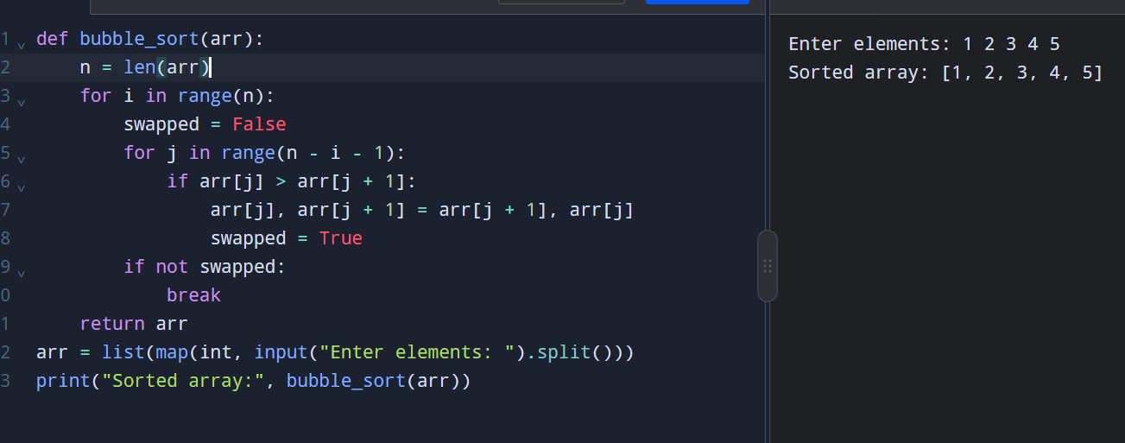
Input:
Enter elements: 1 2 3 4 5
Output:
Sorted array: [1, 2, 3, 4, 5]
Time Complexity:
- Best case: $O\left(n\right)$
- Average and worst case: $O\left(n^{2}\right)$
Space Complexity: $O\left(1\right)$auxiliary space.
Result: The program sorts the array and stops early if no swaps occur during a pass.

